
Contact:
Susan Phillips, President and CEO
904-209-4430 (office)
SPhillips@FloridasHistoricCoast.com
Barbara Golden, Communications Manager
904-669-8142 (cell)
BGolden@FloridasHistoricCoast.com

Florida’s Historic Coast Opens Its Hearts and Doors to Floridians Impacted by Hurricane Milton
St. Augustine, Ponte Vedra and The Beaches offering reduced rates & specials for impacted Florida residents at FHC4U.com
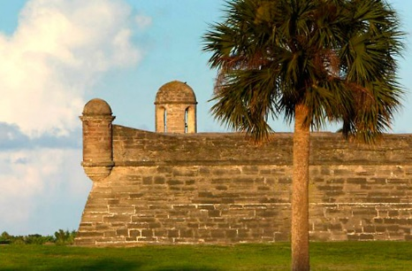
St. Augustine, Fla. (October 14, 2024) — Many Floridians across the state have been profoundly impacted by Hurricane Milton and other recent storms. Florida’s Historic Coast feels and shares their pain as it has endured many similar challenges, recovering from Hurricanes Matthew, Irma, and others. The message for its neighbors is simple—we know what you are going through and we’re here for you.
In light of the extreme damage suffered by much of Florida, the hospitality and tourism community has come together to welcome Florida residents affected by Hurricanes Helene and Milton. With plenty of rooms, locally owned restaurants and coffee shops for dining, and attractions and boutiques that offer a welcome distraction, the area can provide a safe and welcome haven while much of Florida begins the hard work of recovery and rebuilding.
“Our area is extremely fortunate to have escaped with minor damage,” says Susan Phillips, President and CEO of St. Augustine, Ponte Vedra and The Beaches Visitors and Convention Bureau. “We understand that’s not the case across much of our state. Many of our fellow Floridians have lost their homes, the very place where you feel secure and comfortable. In order to help those who helped us in the past, we want to open our doors for our fellow neighbors so they can rest and recover from the shock of this historic storm.”
“Something I’ve always admired is how supportive this community is,” continues Phillips. “We’ve been through damaging storms and know the value of a helping hand. It’s time to offer a hand in any way we can. For visitors, that means opening our community and being warm and welcoming hosts.”
St. Augustine, Ponte Vedra and The Beaches Visitors and Convention Bureau have compiled special accommodations, dining, and activities discounts for displaced Florida residents on a dedicated webpage: www.FHC4U.com
Located midway between Daytona Beach and Jacksonville, Florida's Historic Coast includes historic St. Augustine, the outstanding golf and seaside elegance of Ponte Vedra, the rural beauty of Hastings, Elkton, St. Johns, and 42 miles of pristine Atlantic beaches. Visitor Information Centers are located at 10 Castillo Drive, St. Augustine; 200 Solana Rd. Suite B, Ponte Vedra Beach: and at the St. Johns County Beach Pier Park, 350 A1A Beach Blvd., St. Augustine Beach. For advance travel information, call 1.800.653.2489 or go to the Visitors and Convention Bureau website at www.FloridasHistoricCoast.com. Check us out on social media Instagram @FloridasHistoricCoast; @ViajaStAugustine, Facebook.com/OfficialStAugustine, and Facebook.com/ViajaStAugustine and Twitter @FlHistoricCoast.
# # #

